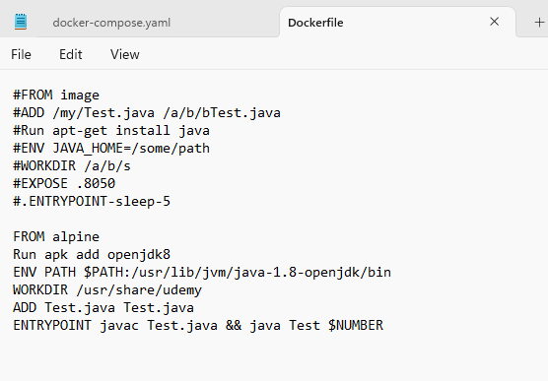

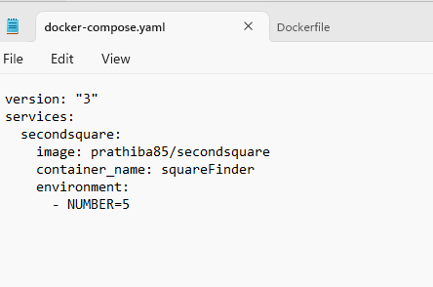

Docker file is working with parameter

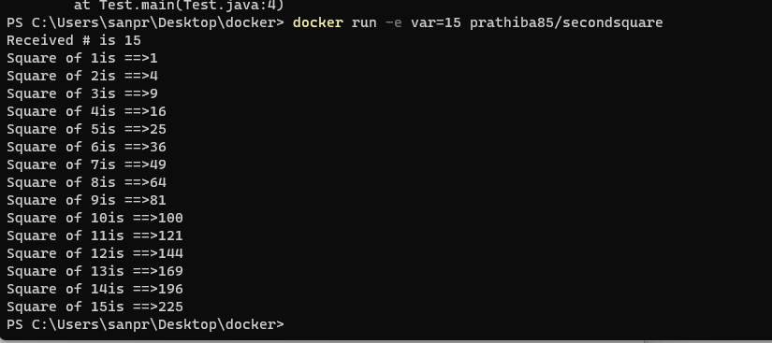

I have three docker images with various tags

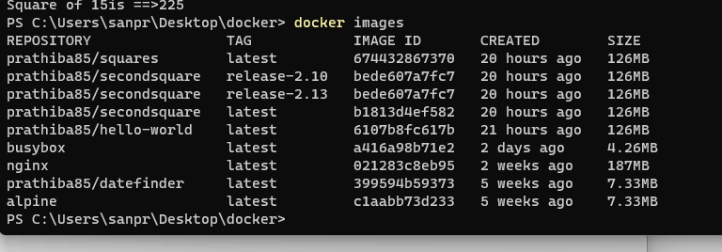

How to compose image – prathiba85/secondsquare (release-2.13) ?

When I give docker compose command now, I am getting error

